This paper has been accepted for presentation at the 2nd International Solar Cities Congress

Social housing electrical energy consumption profiles in the United Kingdom

Nico Kreutzer ^{a,}*, Ian Knight^{b}
ªEnergy Equipment Testing Service Limited, Unit 2 Glan-y-Llyn Industrial Estate, Cardiff Road, Taffs Well CF15 7JD, Wales, UK
^{b}The Welsh School of Architecture, Cardiff University, King Edward VII Avenue, Cardiff CF10 3NB, Wales, UK

*Corresponding author. Tel.: +4402920820910
E-mail address: nkreutzer@eets.co.uk
Fax: +4402920820911

Abstract
Social housing forms a significant part of the overall UK housing stock, and is of interest from an energy efficiency viewpoint as a number of social housing providers are closely examining ways of reducing the energy bills for their tenants – many of whom find these costs to be a significant part of their budget.
This paper presents measured electrical energy consumption profiles for this sector, obtained over a period of 2 years. The measurements were all obtained at 5 minute intervals. Annual energy consumptions, daily and overall profiles were derived for the dwellings from the data. To create a link between the energy consumption profiles and socio-economic factors an occupant survey was undertaken among the people living in the monitored dwellings. The survey included questions regarding the following aspects: the number of tenants living in the household, tenant’s age, ownership of electrical appliances and the general times of use of appliances and occupancy in the household.
It is intended that the results presented in this paper can be used in the quest for an accurate prediction method for electricity consumption for people living in social housing in the UK. This will enable greater confidence in the sizing of, for example, microgeneration systems in this type of housing.

Keywords: Domestic energy consumption; Load profiles; Social housing

- Introduction
The housing stock of the United Kingdom consists of 25 Million households with an annual electricity energy consumption of 115GWh [,]. Around 20 per cent of these dwellings can be considered as part of social housing and, using the UK average of 2.4 occupants per dwelling, it can be estimated that this sector of UK society is represented by 12 million people []. These figures stress the large influence on overall UK domestic electrical energy consumption of this section of society.
The behaviour patterns of people living in the social housing sector usually differ slightly from the average pattern; one indicator of this discrepancy is the rate of employment. National Statistics show that among people from the social housing sector 33% work, where the average of employment in the non-social housing sector (renting from private and owner-occupied) is 60% [Error: Reference source not found].
There have been two reported end use monitoring campaigns in the UK where the electric energy consumption of individual dwellings was obtained. The Load Research Group of the Electricity Association undertook the monitoring of 1200 homes and carried out a occupant survey where the household type, socio-economic characteristics and the ownership level of appliances was recorded []. Based on these data sets a load model for domestic electric energy consumption and load profiles has been developed by Stokes []. Another monitoring campaign was undertaken by Newborough [] where the energy demand data of 30 homes have been obtained. A survey among a sample of over 1000 adults has been conducted mainly in the south-east of England regarding the socio-economic aspects of energy use []. The results of this investigation, such as ownership level, differences in consumption in different classes of the society, and total energy consumption of certain appliances are usually used when modelling of domestic energy is carried out for the UK (for example []).
This paper deals exclusively with the electrical energy consumption of houses within the social sector. The results will be of use in a range of areas, including predicting the potential impact of residential cogeneration systems or renewable energy systems on the energy consumption of this part of the housing stock, and also in checking the accuracy of existing models.

- Data collection
The data for this work is based on 4 monitoring projects with a total number of 90 homes. Monitoring took place between 2002 and 2005 in Newcastle (25 flats/England), Llanelli (18 town-houses and flats/Wales), Nottingham (22 semi-detached houses/England) and Derry (25 semi-detached houses/Northern Ireland). The monitoring duration of each project was 24 months and measurements were taken at 5 minute intervals. The data has been collected by EETS Ltd. [] as part of the Domestic Field Trial Project [Error: Reference source not found] where the performance of PV systems in the domestic sector as well as the electric energy imported and exported from the dwellings was monitored.
Although initially 90 dwellings were monitored, the number of useable records has been reduced by abnormally low or non-occupation of the dwellings to 69 sets.
The floor area of the households varies between 52m² and 124m² with an average of 75m² and the average number of occupants per dwelling is 2.4 (ranging between 1 and 9 people). The dwellings use fossil fuel for space heating. The energy type for cookers and showers varies within the data sets. There are 29 households with electric cookers/showers, 30 households with electric cookers and fossil fuel heated water for the showers and 10 households with fossil fuel powered cookers/showers.

- Overall load profiles and total annual consumption
To understand the range of electricity demand, the averaged daily Winter (January) and Summer (July) profiles for weekday and weekend days, normalised for floor area, are presented in figures 1 to 4 using deviation bars. The range encompassed by the bars is plus and minus one standard deviation from the mean value at that point.

The base load of the demand in the four figures occurs overnight and is mainly from appliances in stand-by mode and appliances driven by a thermostat e.g. refrigerator. This base load ranges between 0W/m²-6W/m². The figures show that there is not a significant difference in terms of base load between Summer/Winter and weekend/weekday.
The main difference between the weekend and weekday profile is the period between 09:00 and 16:00, where the weekend profile shows a higher demand due to higher occupancy.
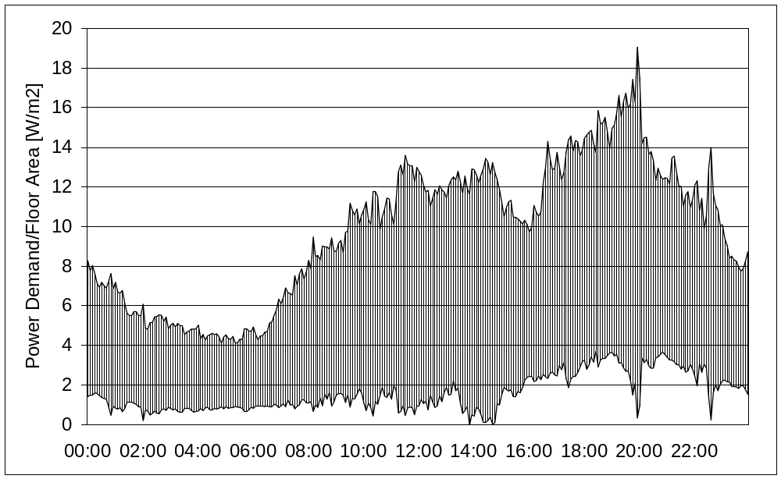
Fig. 1. Normalised overall Winter Weekend profile
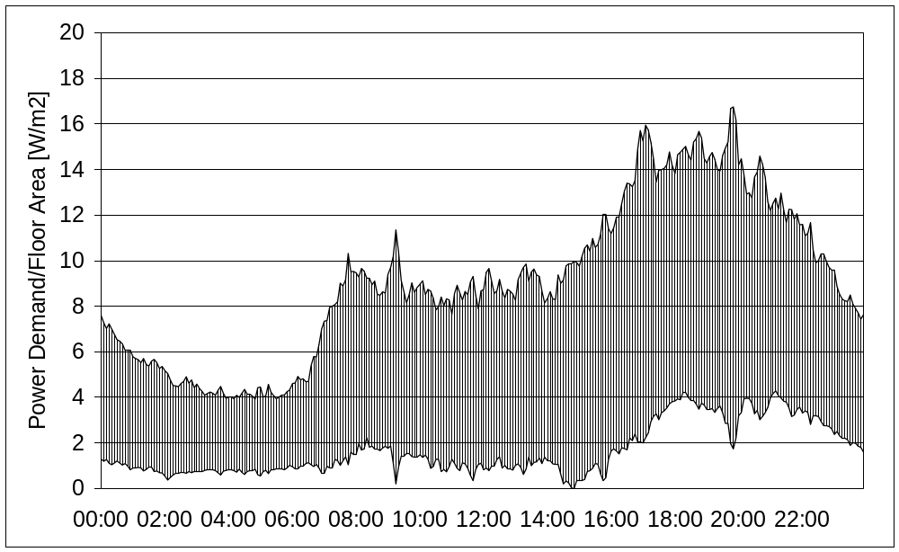
Fig. 2. Normalised overall Winter Weekday profile
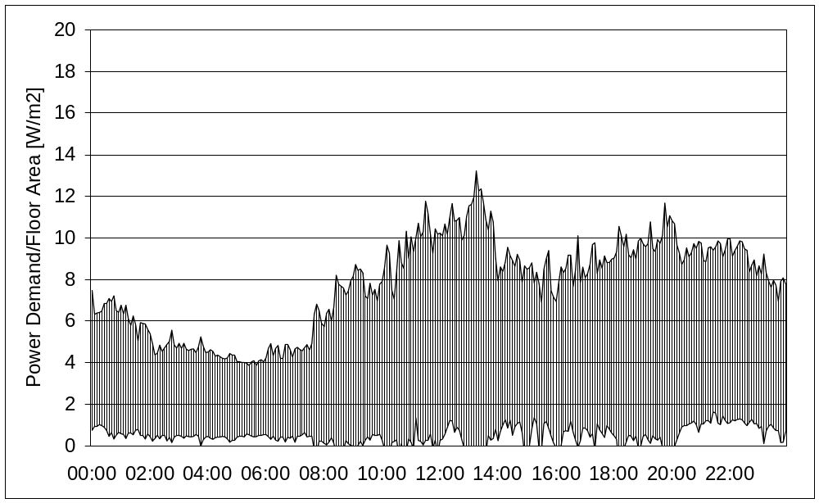
Fig. 3. Normalised overall Summer Weekend profile
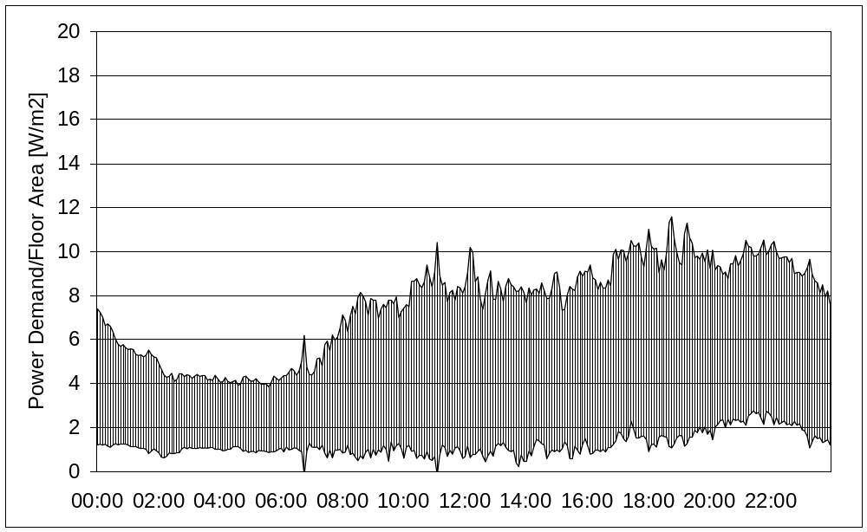
Fig. 4. Normalised overall Summer Weekday profile

Figure 5 compares the hourly profiles of the average power demand for the Winter and Summer season.
The base load period starts at 03:00 and finishes at 06:00 with an average demand of 200W. The Winter Weekday profile shows a considerable morning peak caused by a larger lighting and possibly a space heating-related demand (e.g. pumps). The Summer Weekend profile has a peak around 13:00 when food is usually prepared for lunch. The two Winter power profiles peak at 750W and both represent a daily electrical energy consumption of ~10kWh. The energy consumption of the Summer profiles amounts to ~7.8kWh per day with an evening peak around 450W.

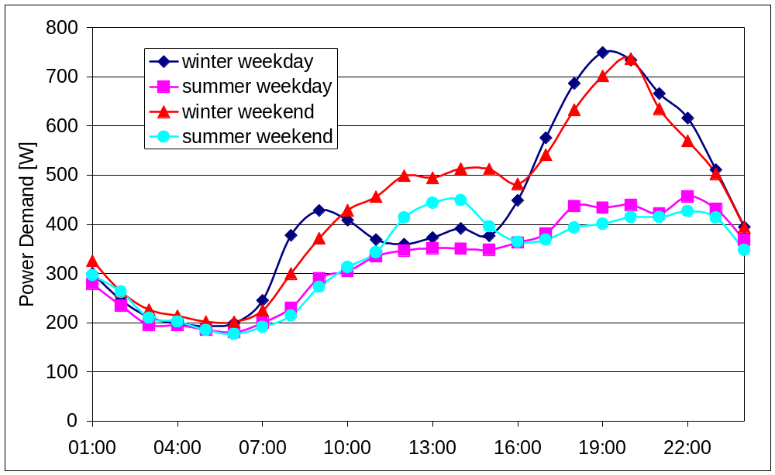
Fig. 5. Comparison of overall Winter and Summer profiles

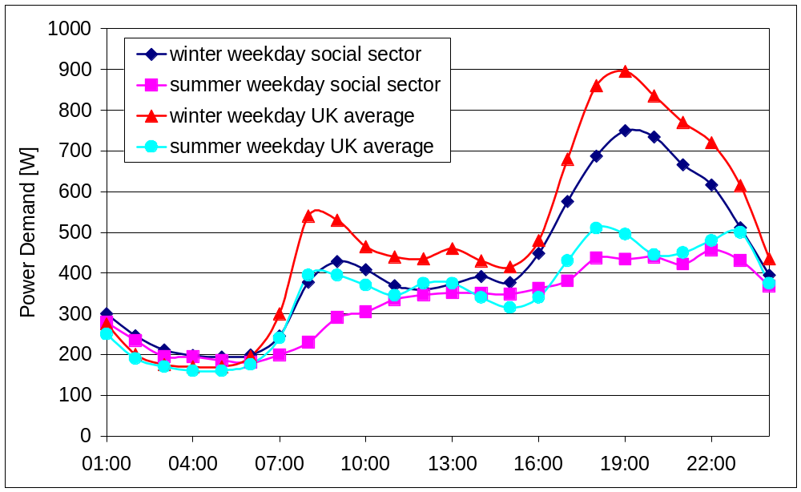
Fig. 6. Comparison of UK average and social sector daily electric energy consumption profiles

Figure 6 presents a comparison of the profiles obtained for the social sector and the profiles recorded by the Electricity Association, here considered to represent the UK average. The figure shows that the period from midnight until 6:00 is very similar; including the base load. Evident is the missing morning peak in the Summer weekday profile of the social housing data and the smoother shape of these records. Unfortunately nothing is known about the ownership level of appliances or the proportion of electrical space heating within the Electricity Association records but it is clear that the typical social sector profile shows a lower energy demand. The energy consumption of a UK average Winter day is around 11.5 kWh, the figure for the social sector amounts to 10 kWh.

Comparison of the annual electrical energy consumption per unit floor area supports this finding. The UK average amounts to ~55 kWh/m²/year (derived from the total domestic consumption, number of households and the average Floor area) whereas the social sector use ~43 kWh/m²/year [Error: Reference source not found,Error: Reference source not found,Error: Reference source not found].

The annual total electric energy consumption of the monitored dwellings varies between ~800kWh and ~7800kWh with an average of ~3100kWh. The average total annual electric energy consumption of the United Kingdom amounts to ~4700kWh per household.

- Analysis of Single Load Profiles

As well as the overall profiles and the total consumption already presented, the base and peak load demands, and the load factor, are further data that are useful in order to optimise the integration of microgeneration systems.
Figure 7 shows the distribution of the monthly average base load demands (December weekday) for all the houses. The data is derived from the monthly averaged electrical load profiles (midnight to 07:00) of each dwelling and it shows that the base load is generally between 50W and 150W.
Figure 8 shows the peak load distribution for the same set of data. The majority of the dwellings have an average maximum electrical power demand between 500W and 1000W. The monthly load factor, which is the ratio between average demand and the peak demand, ranges between 0.15 and 0.52 (average 0.34). This figure provides an indication of the variation in load, with a smaller figure presenting greater variation over the period.

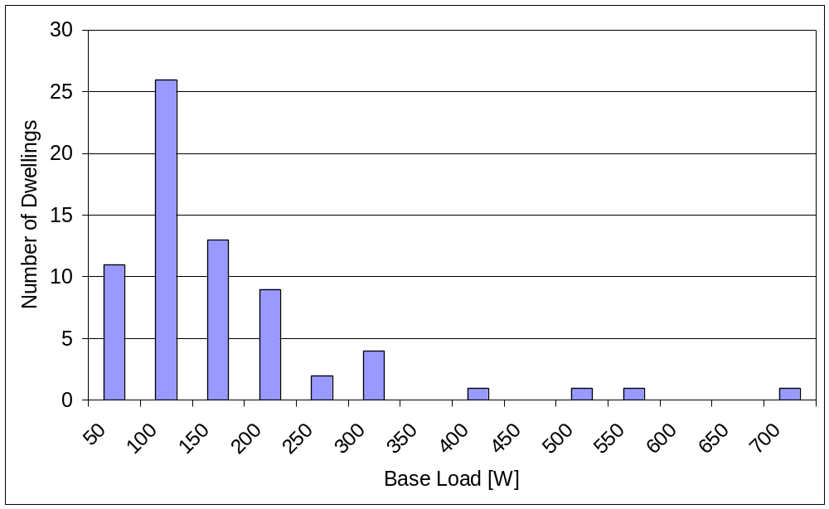
Fig. 7. Distribution of monthly Base Load – Winter Weekday data

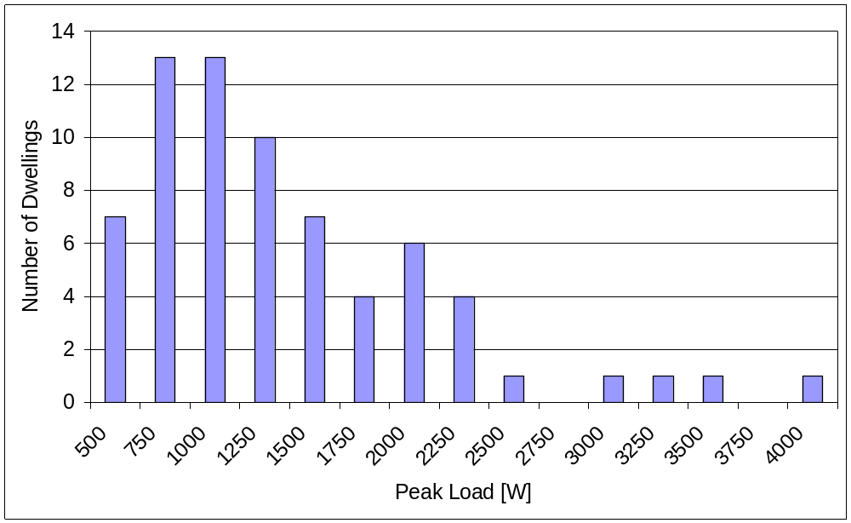
Fig. 8. Distribution of monthly Peak Load – Winter Weekday data

- Occupant survey

The survey was undertaken among the occupants of the monitored dwellings, and 46 out of the 69 households have been interviewed face to face. The composition of the households is shown in Table 1.
The results of the survey indicate that the majority of the interviewed people do not have a fixed pattern of activities during the day. As already noted, this sector has a relatively low percentage of employed people compared to the UK average. This means that, for example, the high power demand activity of clothes washing can be done in the course of the day rather than after work. This uncertain activity pattern is reflected in the size of the standard deviation during the daytime shown in Figures 1 - 4. The overall effect is that the predicted power demand levels can vary by up to 50% from the mean value over the course of a day.

The ownership level of appliances obtained from the survey is compared with the results from Mansouri [Error: Reference source not found] in Table 2. The biggest discrepancy between the UK average and the social housing is the level of dishwashers. The possession of this appliance is likely to be even higher than shown here (data from 1997).
The people living in social housing spend more time watching TV (~10h/day) than the UK average (~5h/day) which is also reflected in the number of TV sets per household.

The possession of vacuum cleaners shown in table 2 is less than one because the interviewed dwellings had partly wooden floors.

The results from the survey give a possible explanation for the overall lower consumption in the social sector. The ownership level of high demand appliances is, according to this occupant survey, lower than the average, taking into consideration that refrigeration and the dishwasher are the main consumers in the household. On the other hand, the possession of low demand appliances, such as TV and DVD player/video, is higher in the social sector than the average.

- Conclusion

This investigation focused on the domestic electrical energy consumption of the social housing sector in the United Kingdom. The data from a survey and a monitoring campaign has been analysed and presented in this work. The monitored dwellings have been characterised regarding floor area, number of occupants and ownership level of appliances. Although the sample size of the investigation is relatively small, it still gives some useful information on the energy usage behaviour. The findings were compared with the available records for the UK average and the analysis indicates that there is a general lower consumption in the social sector. The difference can possibly be explained by the absence of high energy consumers such as dishwashers and a lower ownership level of refrigeration.
The results of the work can be used to investigate the possibilities of integration of microgeneration systems into the dwellings belonging to the social housing sector.

References

[?] National Statistics Online, http://www.statistics.gov.uk
[?] Department of Trade and Industry, http://www.dti.gov.uk
[?] Domestic Energy Fact File 2003, http://projects.bre.co.uk/factfile
[?] Electric Association, Load Research Group, http://www.electricity.org.uk
[?] M. Stokes, A fine-grained load model to supported low voltage network performance analysis, Ph.D. Thesis, De Montfort University, Leicester, 2005.
[?] M. Newborough, P. Augood, Demand-side management opportunities for the UK domestic sector, IEE proceedings generation transmission distribution, 1999, 283-293
[?] I. Mansouri, M. Newborough, D. Probert, Energy Consumption in the UK Housholds: Impact of Domestic Electrical Appliances, Applied Energy 54 (3) (1996) 211-285
[?] R. Yao, K.A. Steemers, A method of formulating energy load profiles for domestic buildings in the UK, Energy and Buildings 37 (2005) 663-671
[?] Energy Equipment Testing Service Ltd., http://www.eets.co.uk Table 1 Composition of surveyed households Family compositionNumber of households1 adult151 adult + 1 child51 adult + 2 children41 adult + 3 or more children42 adults72 adults + 1 child32 adults + 2 children52 adults + 3 or more children3 Table 2 Comparison of appliance ownership levels AppliancesAverage ownership level Social SectorAverage ownership level UK AverageRefrigeration1.351.77TV2.15 (all)1.60 (Colour)DVD player/video1.64 (Video and DVD)0.76 (Video only)Computer0.33-Hi-fi0.74-Electric kettle0.910.90Toaster0.67-Microwave0.870.74Washing machine0.960.93Tumble dryer0.540.53Dishwasher0.090.43Vacuum cleaner 0.96 1.00Iron0.801.00

